

**Post Sessions Survey Results**

**Project Impact**

* **82% of respondents said that the Civility Matters education made a positive impact at the workplace**

**Project helpfulness**

* **On the helpfulness of the Civility Matters Project, respondents rated the session content 6/10** with a wide range (1/10 – 10/10);
* **12 of the 28 respondents rated it >8/10**

**Main take home points identified by respondents**

* + Tips to use in the moment (breath, posture, curiosity, power of the pause),
  + not take things personally,
  + it is not about you,
  + address work environment is a team event,
  + take accountability for how we show up,
  + all we can control is ourselves,
  + 24-72 hour guideline for discussing an event,
  + avoid silence and condoning behaviour,
  + standing with others,
  + clarifying phrases to dispel misinterpretations

**What do you wish there was more of and/or less of, as part of the Civility Matters Project?**

* Respondents expressed a desire for **MORE** of:
  + examples of how to deal with difficult behaviour,
  + more scenarios,
  + physician attendance,
  + tips to build better relationships,
  + dealing with burnout,
  + group activities
* Respondents expressed a desire for **LESS** of:
  + the ball,
  + scenarios,
  + reduce time gap between sessions,
  + pick and choosing which sessions to attend

**Session length**

* **89% of respondents felt that the sessions were about the right length;**
* **11% felt they were too short**

**Session frequency going forward**

* **Going forward 50% of respondents favor a follow-up session on a quarterly basis,**
* **20% opt for no more sessions**

**How respondents feel now…**

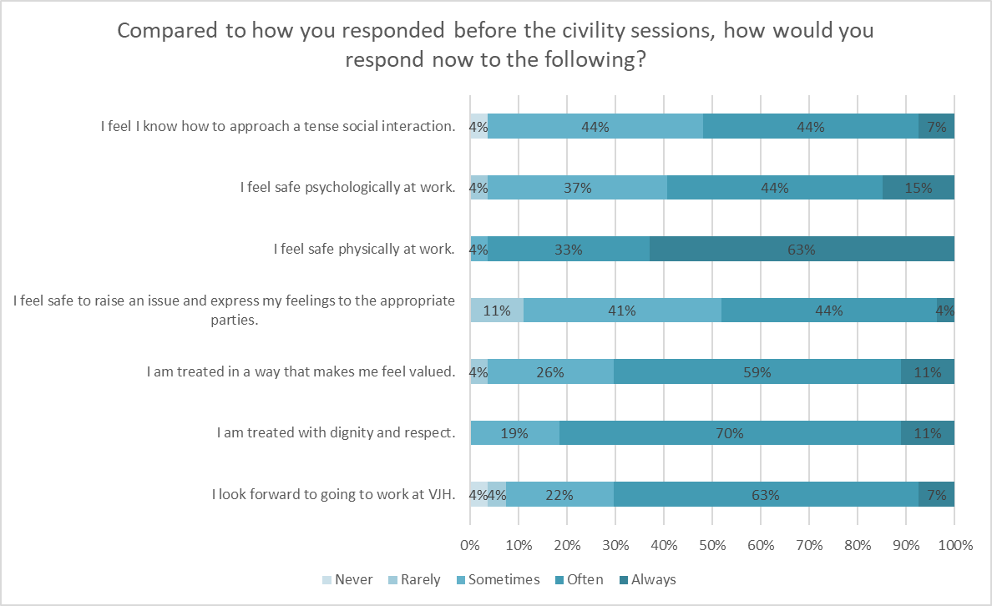

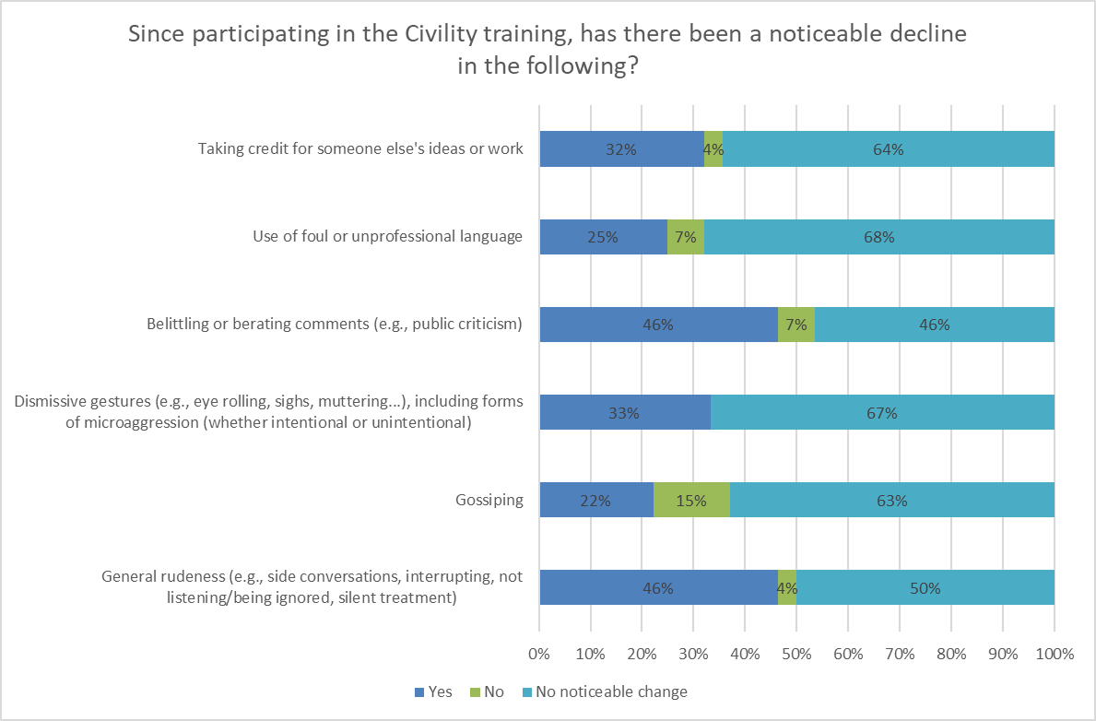

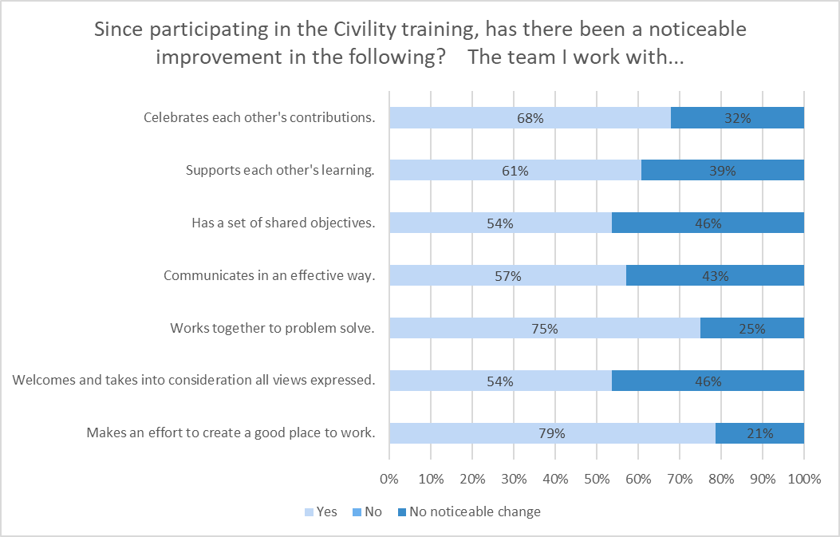

**Your Responses…**

**Of the 25 comments, 21 were supportive of the project and 4 were not**

(Please know that your department leadership has ***all*** of the data, including all comments)

* “That it’s a great program and that every department should experience the project”
* “It’s a step in the right direction and helpful learning new strategies”
* “That it is a useful resource to consider utilizing to help create a more harmonious work place.”
* “It was wonderful, it was a way to relearn how to engage with difficult behaviour, called us on our own behaviour, opened our eyes to how words/actions might be portrayed and not meant, gave clarity to our actions moving forward, how to move on from bad re-occuring behaviours”.
* “Very beneficial to be aware of common patterns/civility/incivility in healthcare. Also to acknowledge personality traits while dealing with conflict, and tools to help with same.”
* “When difficult situations arise, civility is mentioned and talked about, how to do things right.”
* “A fantastic learning experience, and so empowering to know we ALL had the same training
* “A lot of fluff. Not particularly helpful. Would not recommend”
* “Very little impact”

**Thank you for participating in the project and for reviewing this**

**Your Civility Matters Team**

